INTERNSHIP PROJECT REPORT
ON
Password Cracking & Credential Attack Suite
Submitted as part of the Cyber Security Internship Program

Internship Period
December 2025 – June 2026

Supervised By: Submitted By:
Mr. Harshit Ravi
Organization:
Unified Mentor
INDEX

Sr. No. | Title | Page No.
1. | Abstract | 4
2. | Introduction | 5-6
3. | Problem Statement | 7
4. | Project Objective | 8
5. | Scope of the Project  - 5.1 In Scope  - 5.2 Out of Scope | 9
6. | Tools & Technologies Used | 10
7. | Methodology / Workflow | 11-13
8. | Implementation Details | 14-17
9. | Results & Findings | 18
10. | Security Recommendations | 19
11. | Learning Outcomes | 20
12. | Conclusion | 21
13. | Future Enhancements | 22
14. | References | 23

List of Figures

Figure No. | Description | Page No.
Figure 7.1 | System Architectue Diagram | 13
Figure 8.1 | Project Structure | 14
Figure 8.2 | Program Start Screen | 15
Figure 8.3 | Dictionary Generator | 15
Figure 8.4 | Password Strength Analysis | 16
Figure 8.5 | Brute-Force Attack Module | 16
Figure 8.6 | Dictionary Attack Module | 17
Figure 8.7 | Hash Algorithm | 17
Figure 8.8 | Report Generation | 17

1. ABSTRACT
The Password Cracking & Credential Attack Suite is a cybersecurity-based project designed to simulate and analyze password security vulnerabilities in a controlled and ethical environment. Passwords remain one of the most widely used authentication mechanisms, yet weak password practices continue to be a major cause of security breaches, account takeovers, and unauthorized access. This project aims to provide a practical understanding of how attackers exploit weak credentials and how security professionals can detect and mitigate such risks.
The system integrates multiple modules including a dictionary generator, password strength analyzer, brute-force attack simulator, hash processing module, and report generation system. The dictionary generator creates customized wordlists based on user-defined inputs such as names and dates of birth, along with common password patterns. These wordlists are used to simulate dictionary-based attacks. The password strength analyzer evaluates passwords based on complexity rules and entropy, categorizing them as weak, medium, or strong.
The brute-force simulation module demonstrates how attackers attempt all possible combinations to guess passwords, highlighting the impact of password length and character diversity on security. Additionally, the hash module simulates the process of identifying and cracking hashed passwords using predefined datasets, providing insight into how credentials are stored and verified in real systems.
The system generates a comprehensive security audit report that includes identified weak passwords, attack simulation results, and recommendations for improving password policies. This project helps bridge the gap between theoretical cybersecurity concepts and practical implementation by providing hands-on experience in password auditing and attack simulation.
Furthermore, the project emphasizes the importance of secure authentication practices in modern digital systems. It demonstrates how even small weaknesses in password design can lead to significant security risks. By simulating real-world attack scenarios and providing actionable recommendations, the system encourages users and organizations to adopt stronger password policies and multi-layered security mechanisms. This makes the project not only a learning tool but also a practical approach toward improving overall cybersecurity awareness and resilience.

2. INTRODUCTION
In the modern digital era, authentication plays a critical role in securing systems, applications, and sensitive user data. Among various authentication mechanisms, passwords remain the most widely used method due to their simplicity and ease of implementation. However, despite their popularity, passwords are often the weakest link in the security chain. Poor password practices such as using short, predictable, or commonly used passwords significantly increase the risk of unauthorized access and cyber-attacks.
With the rapid growth of internet services, cloud computing, and online platforms, the number of cyber threats has also increased exponentially. Attackers frequently exploit weak passwords through techniques such as brute-force attacks, dictionary attacks, and credential stuffing. These attacks aim to gain unauthorized access to user accounts, leading to data breaches, financial loss, identity theft, and compromise of confidential information. Therefore, it is essential to understand how these attacks work and how they can be prevented through stronger authentication mechanisms.
The Password Cracking & Credential Attack Suite is designed to provide a practical and educational approach to understanding password-related vulnerabilities. This project focuses on simulating real-world password attack techniques in a controlled and ethical environment. Instead of performing actual malicious activities, the system demonstrates how attackers attempt to crack passwords and how defenders can analyze and strengthen password security. This dual perspective helps in understanding both offensive (attack) and defensive (protection) aspects of cybersecurity.
The project is structured into multiple functional modules, each addressing a specific aspect of password security. The dictionary generator module creates customized wordlists based on user inputs such as names, dates of birth, and common password patterns. This demonstrates how attackers generate targeted password lists for efficient attacks. The brute-force simulator systematically attempts all possible combinations within a defined limit, highlighting the computational complexity involved in cracking passwords.
Another important component of the system is the password strength analyzer, which evaluates passwords based on complexity rules such as length, use of uppercase and lowercase letters, numbers, and special characters. It also calculates entropy, which is a measure of randomness and unpredictability. This helps in determining how secure a password is and how resistant it is to attacks. Additionally, the hash module simulates how passwords are stored in encrypted form using hashing algorithms and demonstrates how attackers attempt to crack these hashes using dictionary-based techniques.
The project also includes a report generation module that produces a comprehensive security audit report. This report contains details about weak passwords, results of attack simulations, and recommendations for improving password security. Such reports are useful for organizations to assess their security posture and implement better authentication policies.
This project is highly relevant in the field of cybersecurity education and training. It bridges the gap between theoretical knowledge and practical implementation by providing hands-on experience with password attack techniques and defense strategies. It enables students and learners to understand the importance of strong password policies, multi-factor authentication, and secure storage mechanisms.
Furthermore, the project emphasizes ethical considerations and responsible use of cybersecurity tools. All simulations are performed in a controlled environment using sample data to ensure that no real systems or users are affected. This promotes awareness about ethical hacking practices and encourages the use of knowledge for defensive and protective purposes only.
In conclusion, the Password Cracking & Credential Attack Suite serves as a comprehensive learning tool that demonstrates the significance of password security in modern computing environments. By combining multiple modules such as dictionary generation, brute-force simulation, hash processing, and strength analysis, the project provides a complete framework for understanding, analyzing, and improving authentication security. It not only highlights the risks associated with weak passwords but also provides practical solutions to enhance overall system security.

3. PROBLEM STATEMENT
In today’s digital environment, passwords serve as the primary method of authentication for accessing systems, applications, and sensitive data. Despite advancements in security technologies, a large number of users continue to rely on weak, predictable, and easily guessable passwords. Common practices such as using short passwords, reusing the same password across multiple platforms, and relying on personal information (e.g., names, dates of birth) significantly increase the risk of unauthorized access. These weaknesses make systems highly vulnerable to various types of cyber-attacks.
Attackers exploit these vulnerabilities using techniques such as brute-force attacks, dictionary attacks, and credential stuffing. In a brute-force attack, all possible combinations of characters are systematically tested until the correct password is found. Dictionary attacks use precompiled lists of commonly used passwords to quickly guess credentials. Credential stuffing involves using leaked username-password pairs from previous data breaches to gain access to other accounts. These attack methods are highly effective against weak passwords and can lead to serious consequences such as data breaches, identity theft, financial loss, and compromise of confidential information.
Another major issue is the lack of awareness among users regarding password strength and security practices. Many users are unaware of how passwords are stored, typically in the form of hashed values, and how attackers attempt to crack these hashes. Additionally, organizations often fail to enforce strong password policies or conduct regular security audits, further increasing the risk of exploitation.
To address these challenges, there is a need for a system that can simulate password attack techniques in a safe and controlled environment while also providing tools to analyze and improve password security. Such a system should enable users to generate test password datasets, evaluate password strength, simulate brute-force and dictionary-based attacks, and analyze hashed credentials.
Therefore, the problem lies in the absence of a practical, user-friendly, and integrated platform that demonstrates password vulnerabilities, attack methodologies, and defensive strategies in a single system. The proposed Password Cracking & Credential Attack Suite aims to solve this problem by offering a comprehensive toolkit that bridges the gap between theory and practice, enhances cybersecurity awareness, and promotes the adoption of strong password practices.
4. PROJECT OBJECTIVES
The primary objective of the Password Cracking & Credential Attack Suite is to design and develop a system that simulates password attack techniques and evaluates authentication security in a controlled and ethical environment. The project aims to provide practical understanding of how weak passwords can be exploited and how such vulnerabilities can be reduced through strong security practices.
One of the main objectives is to develop a dictionary generator that creates customized password wordlists based on user inputs such as names, dates of birth, and common password patterns. This demonstrates how attackers generate targeted password lists to perform efficient attacks. The project also aims to include variations such as numbers, symbols, and uppercase characters to mimic real-world scenarios.
Another objective is to build a password strength analyzer that evaluates passwords based on parameters like length, complexity, and randomness. It calculates entropy to measure unpredictability and classifies passwords as weak, medium, or strong, helping users understand the importance of secure password creation.
The project also focuses on implementing a brute-force simulation module that attempts multiple password combinations within a defined limit. This highlights how password length and complexity affect the time required for cracking. Additionally, the system demonstrates dictionary-based attacks to show how commonly used passwords can be easily compromised.
An important objective is to simulate password hashing and verification through a hash module. This helps in understanding how passwords are securely stored and how attackers attempt to crack hashed credentials using dictionary techniques in a controlled environment.
Finally, the project aims to generate a detailed security audit report that summarizes analysis results, identifies weak passwords, and provides recommendations to improve password security. It also helps users and organizations evaluate their current password policies and identify potential risks. The system is designed to be simple, modular, and easy to use for educational purposes. Overall, the objective is to bridge the gap between theoretical knowledge and practical implementation while promoting cybersecurity awareness and ethical practices.

5. SCOPE OF THE PROJECT
The scope of the Password Cracking & Credential Attack Suite is to provide a practical platform for understanding password security and common attack techniques in a controlled and ethical environment. The project focuses on simulating how weak passwords can be identified and exploited, while also demonstrating methods to improve password strength and security practices. It includes features like password generation, strength analysis, attack simulation, and result reporting for educational purposes.
The system allows users to generate password wordlists based on common patterns and analyze password strength using basic rules and entropy. It also demonstrates brute-force and dictionary-based attack simulations to highlight how passwords can be cracked. Additionally, a hash module is included to show how passwords are stored securely and tested against attacks in a safe manner.
5.1 In-Scope
- Password wordlist generation based on user input
- Password strength checking using complexity rules
- Simulation of brute-force and dictionary attacks
- Basic hash generation and verification
- Security report generation in local environment
5.2 Out-of-Scope
- Real-world hacking or unauthorized system access
- Advanced tools like GPU-based password cracking
- Network attacks such as sniffing or MITM
- Multi-factor authentication bypass
- Any illegal or unethical usage
Overall, the project is limited to educational use and aims to build awareness about password security and safe practices.

6. Tools & Technologies Used
- Python Programming Language:- Used as the core development language for implementing all modules such as brute-force attack, dictionary attack, password analysis, and hash processing due to its simplicity and powerful libraries.
- Visual Studio Code (VS Code):- Used as the primary code editor for writing, debugging, and managing the project efficiently with extensions and integrated terminal support.
- Python Standard Libraries:- Libraries such as itertools, hashlib, time, and random are used for generating password combinations, hashing, measuring execution time, and creating variations.
- Hashing Algorithms (MD5, SHA-1, SHA-256):- Used to simulate secure password storage and demonstrate how hashed passwords can be tested against attacks.
- Wordlist/Dataset (Custom Dictionary):- User-generated and predefined password lists are used for performing dictionary-based attacks and testing password strength.
- Modular Programming Approach:- The project follows a modular structure where each functionality (dictionary generator, brute-force, hash module, analyzer) is implemented separately for better organization and scalability.
- Basic File Handling (Text Files):- Used for storing generated wordlists, logs, and reports in a simple and readable format.
- Security Concepts (Ethical Hacking Basics):- Fundamental cybersecurity concepts are applied to simulate attacks responsibly and understand real-world password vulnerabilities.
Overall, these tools and technologies are chosen to keep the project simple, efficient, and suitable for learning as well as practical demonstration.

7. Workflow / Architecture
The workflow and architecture of the Password Cracking & Credential Attack Suite are designed in a modular and systematic manner to simulate password attacks and analyze credential security in a controlled environment. The system follows a step-by-step process where user input is processed through different modules, each responsible for a specific functionality. This modular design ensures flexibility, scalability, and ease of understanding.
7.1 Overall System Architecture
The architecture of the system is divided into multiple independent modules that work together to achieve the final objective. The main components include:
- User Interface (CLI आधारित Input System)
- Dictionary Generator Module
- Password Strength Analyzer
- Brute-Force Attack Module
- Hash Processing Module
- Report Generation Module
Each module performs a specific task and passes the output to the next stage, forming a complete workflow pipeline.
7.2 Workflow of the System
The workflow begins when the user runs the main program using the command line interface. The system prompts the user to enter basic details such as target name or password for simulation.
Step 1: User Input:- The user provides input such as name, password, or custom keywords. This input is used as the base for generating password patterns and performing analysis.
Step 2: Dictionary Generation:- The dictionary generator creates a list of possible passwords using the provided input. It applies variations such as adding numbers, symbols, and uppercase/lowercase combinations. This simulates how attackers prepare targeted wordlists.
Step 3: Password Strength Analysis:- The entered password is analyzed based on length, complexity, and entropy. The system classifies the password as weak, medium, or strong, helping users understand its security level.
Step 4: Brute-Force Attack Simulation:- The brute-force module attempts to guess the password by generating all possible combinations within a defined limit. It records the number of attempts and time taken, showing how complexity impacts security.
Step 5: Dictionary Attack Simulation:- The system checks whether the password exists in the generated or predefined wordlist. If found, it indicates that the password is vulnerable to dictionary attacks.
Step 6: Hash Processing Module:- The password is converted into a hash using algorithms like MD5 or SHA-256. The system then attempts to match the hash using the generated wordlist, simulating real-world credential verification and cracking techniques.
Step 7: Report Generation:- Finally, the system generates a report summarizing all results, including password strength, attack outcomes, time taken, and security recommendations.

7.3 Module Interaction
Each module in the system is interconnected but functions independently. The output of one module becomes the input for another:
- Dictionary Generator → Used by Dictionary Attack & Hash Module
- Password Analyzer → Provides input for report generation
- Brute-Force Module → Generates attack statistics
- Hash Module → Demonstrates secure storage and cracking
This interaction ensures smooth data flow and efficient execution.
7.4 Architectural Design Approach
The project follows a modular architecture approach, where each functionality is separated into different files or modules. This approach provides several advantages:
- Easy to understand and maintain
- Reusable code structure
- Simplified debugging and testing
- Scalability for future enhancements
The system is designed to run locally without requiring internet access, ensuring safety and ethical usage.

7.5 Data Flow Description
The data flow in the system is linear and controlled:
User Input → Dictionary Generation → Password Analysis → Attack Simulation → Hash Processing → Report Generation
At each stage, data is processed and enhanced before being passed to the next module. Intermediate results are stored temporarily and used for final reporting.

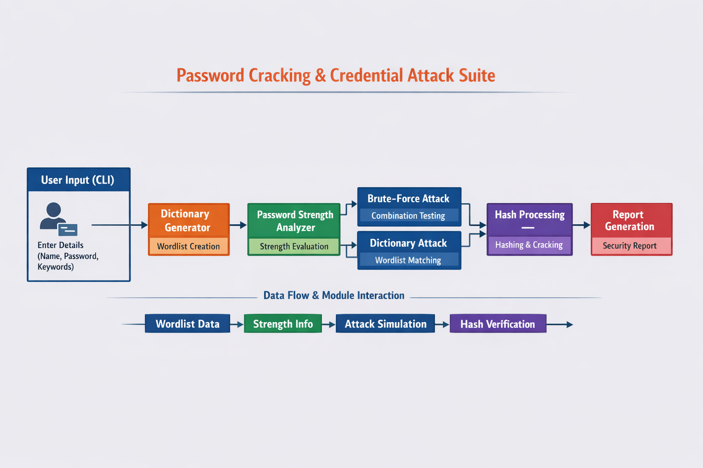
Fig 7.1 – Architecture Diagram
8. Implementation Details
The implementation of the Password Cracking & Credential Attack Suite is carried out using a modular approach in Python, where each functionality is divided into separate modules for better organization and efficiency. The system is executed through a command-line interface (CLI), allowing the user to interact with different features step-by-step.

8.1 Project Setup and Structure
The project is developed in Visual Studio Code on a Windows environment. The folder structure is organized into multiple files such as:
- main.py (Main execution file)
- dictionary_generator.py
- password_analyzer.py
- brute_force.py
- hash_module.py
- report_generator.py
Each file handles a specific task, making the system easy to manage and extend.
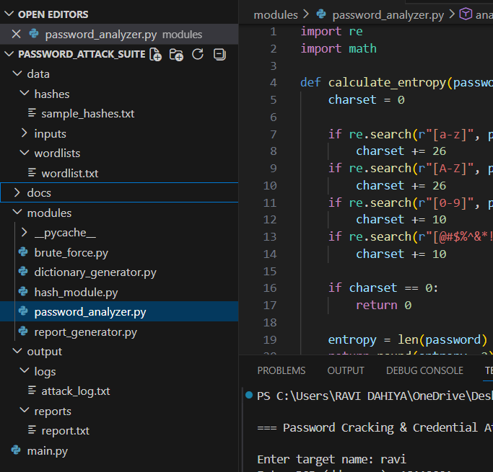
Fig 8.1 – Project Structure
8.2 Main Execution Module (main.py)
The main module controls the entire workflow. When the program starts, it displays a title and prompts the user to enter input such as target name or password. Based on the input, it calls different modules sequentially.
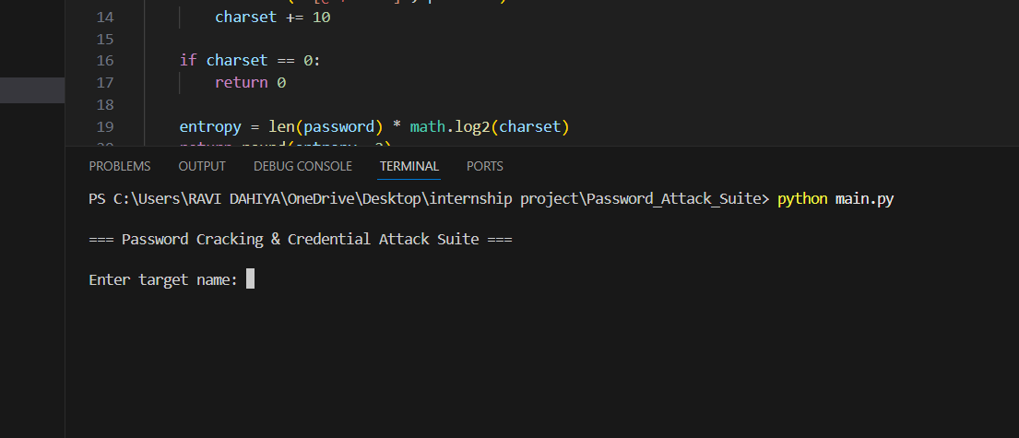
Fig 8.2 – Program Start Screen

8.3 Dictionary Generator Implementation
This module generates password wordlists using user input. It creates variations like adding numbers, symbols, and uppercase letters. This simulates real-world password guessing strategies.
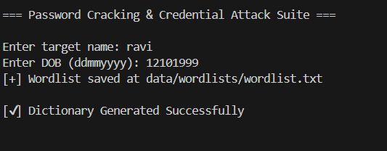
Fig 8.3 – Dictionary Generator

8.4 Password Strength Analyzer
This module checks password strength using parameters like length, uppercase/lowercase letters, digits, and symbols. It also calculates entropy to determine password security level.
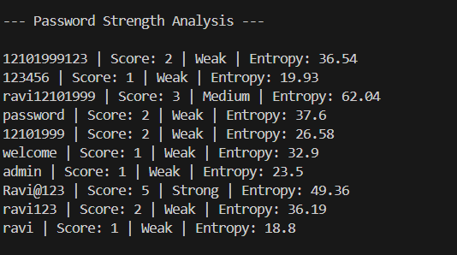
Fig 8.4 – Password Strength Analysis

8.5 Brute-Force Attack Module
This module simulates brute-force attacks by trying multiple combinations to guess the password. It records attempts and time taken.
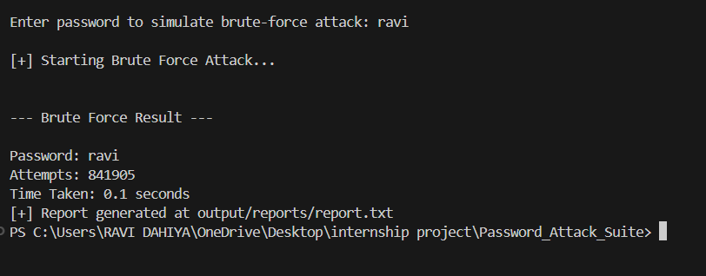
Fig 8.5 – Brute-Force Attack Module

8.6 Dictionary Attack Module
This module checks whether the password exists in the generated wordlist. If found, it indicates vulnerability.
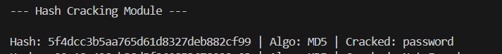
Fig 8.6 – Dictionary Attack Module

8.7 Hash Module Implementation
This module converts passwords into hashes using algorithms like MD5 or SHA-256 and then attempts to match them using dictionary attacks.
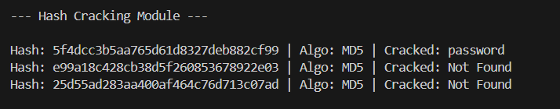
Fig 8.7 – Hash Module

8.8 Report Generation Module
This module generates a final report summarizing all results including password strength, attack results, and recommendations.
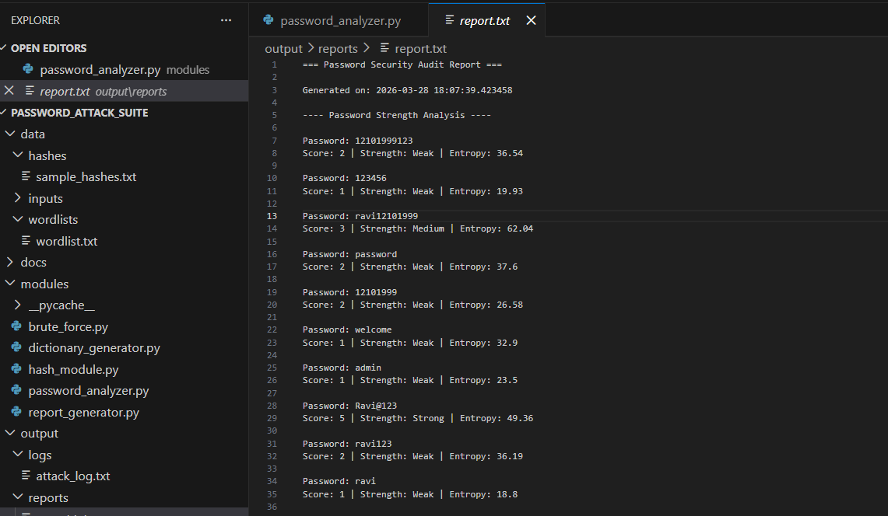
Fig 8.8 Report Generation
9. Results and Findings
The Password Cracking & Credential Attack Suite was successfully implemented and tested in a controlled environment. The system demonstrated how weak passwords can be easily identified and compromised using different attack techniques such as dictionary attacks, brute-force attacks, and hash-based cracking. The results obtained from the execution of various modules highlight the importance of strong password practices.
During testing, it was observed that commonly used passwords such as “123456”, “password”, and simple combinations of names and dates of birth were quickly detected as weak by the password strength analyzer. These passwords also showed low entropy values, indicating poor randomness and high vulnerability. In contrast, passwords containing a mix of uppercase letters, lowercase letters, numbers, and special characters were classified as strong and were more resistant to attacks.
The dictionary attack module successfully cracked passwords that were present in the generated wordlist, proving that users who rely on predictable patterns are at high risk. Similarly, the brute-force attack module demonstrated that shorter and simpler passwords require significantly less time and fewer attempts to crack, whereas complex passwords increase the computational effort required.
The hash module results showed that hashed passwords can be reversed if the original password exists in the dictionary, emphasizing the importance of using strong hashing techniques along with salting in real-world systems. Some hashes were not cracked, indicating that strong or uncommon passwords provide better security.
The final report generated by the system provided a comprehensive summary of all results, including password strength, attack success or failure, and recommendations for improvement. Overall, the findings clearly indicate that weak passwords are highly vulnerable to attacks, while strong and complex passwords significantly enhance security. The project effectively demonstrates real-world password vulnerabilities and highlights the need for better authentication practices.

10. Security Recommendations
Based on the results and findings of the Password Cracking & Credential Attack Suite, several important security recommendations can be made to improve password protection and reduce the risk of credential-based attacks. These recommendations are essential for both individual users and organizations to enhance their overall cybersecurity posture.
One of the most important recommendations is to use strong and complex passwords. A secure password should include a combination of uppercase letters, lowercase letters, numbers, and special characters. Password length should be at least 8–12 characters or more to increase resistance against brute-force attacks. Avoid using common passwords such as “123456”, “password”, or personal information like names and dates of birth, as these can be easily guessed using dictionary attacks.
Another key recommendation is to implement multi-factor authentication (MFA). Even if a password is compromised, MFA adds an additional layer of security by requiring a second verification step such as an OTP or authentication app. This significantly reduces the chances of unauthorized access.
Users should also avoid reusing passwords across multiple accounts. If one account is compromised, reused credentials can lead to further breaches. It is recommended to use unique passwords for different platforms and consider using password managers to securely store and manage them.
From a system perspective, passwords should never be stored in plain text. Instead, secure hashing algorithms such as SHA-256 or bcrypt should be used along with salting to protect stored credentials. This ensures that even if data is leaked, it becomes difficult for attackers to retrieve original passwords.
Regular password updates and security audits are also recommended. Organizations should enforce password policies that require periodic changes and check for weak passwords in their systems. Additionally, limiting login attempts and implementing account lockout mechanisms can help prevent brute-force attacks.
User awareness plays a crucial role in cybersecurity. Individuals should be educated about safe password practices, phishing attacks, and the importance of protecting their credentials. Avoid sharing passwords and always verify the authenticity of websites before entering sensitive information.
11. Learning Outcomes
The development of the Password Cracking & Credential Attack Suite provided valuable learning outcomes in both theoretical and practical aspects of cybersecurity. This project helped in understanding how password-based authentication systems work and how they can be vulnerable to different types of attacks if not properly secured.
One of the key learnings from this project is the practical implementation of password attack techniques such as brute-force and dictionary attacks. It gave clear insight into how attackers attempt to guess passwords using automated tools and how weak passwords can be easily compromised. This hands-on experience strengthened the understanding of real-world security threats.
Another important outcome is gaining knowledge about password strength analysis. The project demonstrated how factors like password length, complexity, and randomness affect security. Learning how to calculate entropy and classify passwords as weak, medium, or strong helped in understanding the importance of secure password creation.
The implementation of hashing techniques provided knowledge about how passwords are stored securely in real systems. Understanding hashing algorithms such as MD5 and SHA-256, along with the concept of salting, highlighted the importance of protecting user credentials from unauthorized access.
The project also improved programming skills, especially in Python. It involved working with modules, functions, file handling, and standard libraries, which enhanced coding efficiency and problem-solving abilities. The modular approach used in the project helped in learning how to structure and organize code effectively.
In addition, the project increased awareness about ethical hacking practices. It emphasized the importance of performing security testing in a controlled environment and using such knowledge responsibly. This helped in developing a strong foundation in cybersecurity ethics.
Finally, the project bridged the gap between theoretical concepts and practical implementation. It provided a deeper understanding of how password security works in real-world applications and how vulnerabilities can be identified and mitigated. Overall, the learning outcomes of this project contribute significantly to building skills in cybersecurity and secure software development.
12. Conclusion
The Password Cracking & Credential Attack Suite project was successfully designed and implemented to demonstrate various password attack techniques and analyze credential security in a controlled and ethical environment. The project effectively highlights how weak passwords can be easily exploited using methods such as brute-force attacks, dictionary attacks, and hash-based cracking.
Through the implementation of different modules, the system provides a complete understanding of password security, starting from password generation to vulnerability analysis and final reporting. The results clearly show that simple and commonly used passwords are highly vulnerable, while strong and complex passwords significantly improve security. This emphasizes the importance of using secure password practices in real-world applications.
The project also demonstrates how password strength can be evaluated using parameters like length, complexity, and entropy. Additionally, the use of hashing techniques provides insight into how credentials are securely stored and why proper encryption methods are essential for protecting sensitive data.
Another important aspect of this project is its educational value. It bridges the gap between theoretical knowledge and practical implementation by allowing users to experience how password attacks work and how they can be prevented. The modular design of the system makes it easy to understand, maintain, and extend for future improvements.
Furthermore, the project promotes ethical hacking practices by ensuring that all simulations are performed using sample data in a safe environment. It encourages responsible use of cybersecurity knowledge and raises awareness about potential threats and preventive measures.
In conclusion, this project successfully demonstrates the importance of strong authentication mechanisms and secure password management. It provides a solid foundation for understanding credential-based attacks and highlights the need for continuous improvement in cybersecurity practices to protect digital assets from evolving threats.

13. Future Enhancements
The Password Cracking & Credential Attack Suite can be further improved and expanded with several advanced features to enhance its functionality, performance, and real-world applicability. Although the current system effectively demonstrates basic password attack techniques and security analysis, there is significant scope for future development.
One of the major enhancements can be the integration of advanced password cracking tools such as GPU-based processing. This would significantly improve the speed of brute-force and dictionary attacks, allowing the system to handle more complex passwords efficiently. Additionally, incorporating larger and more realistic password datasets can make the attack simulations closer to real-world scenarios.
Another important improvement is the implementation of multi-factor authentication (MFA) simulation. This would help demonstrate how additional layers of security can prevent unauthorized access even if passwords are compromised. It would also enhance the educational value of the project by covering modern authentication mechanisms.
The project can also be upgraded by adding a graphical user interface (GUI) instead of a command-line interface. A user-friendly interface would make the system more interactive and accessible, especially for non-technical users. Features like dashboards, visual charts, and real-time attack progress indicators can improve usability and presentation.
Further enhancements may include integrating network-based attack simulations such as credential sniffing or login attempt monitoring in a safe environment. This would provide a broader understanding of cybersecurity threats beyond password-based attacks.
Another valuable addition would be the implementation of advanced hashing techniques such as bcrypt with salting. This would allow users to understand modern password storage mechanisms and compare them with weaker algorithms like MD5.
The reporting module can also be improved by generating detailed reports in multiple formats such as PDF or HTML with visual representations of results. This would make the project more suitable for professional use and presentations.
Finally, the system can be extended to include real-time security recommendations and automated alerts for weak passwords. This would make the project more practical for security auditing and monitoring purposes.
14. References
- Stallings, William. Cryptography and Network Security: Principles and Practice. Pearson Education.
- Bishop, Matt. Computer Security: Art and Science. Addison-Wesley.
- The Web Application Hacker's Handbook – Dafydd Stuttard and Marcus Pinto.
- OWASP. Password Security Guidelines and Best Practices.
- National Institute of Standards and Technology. Digital Identity Guidelines (NIST SP 800-63).
- Python Software Foundation. Python Documentation.
- Hashcat Documentation.
- John the Ripper Documentation.
- Behl, Abhishek. Cybersecurity and Cyberwar: What Everyone Needs to Know. Oxford University Press.
- Online tutorials and research articles related to password security, hashing algorithms, and ethical hacking practices.

